**Client Application**

**Application Route**: https://app-config.labash.inbcu.com

**App name**: app-config

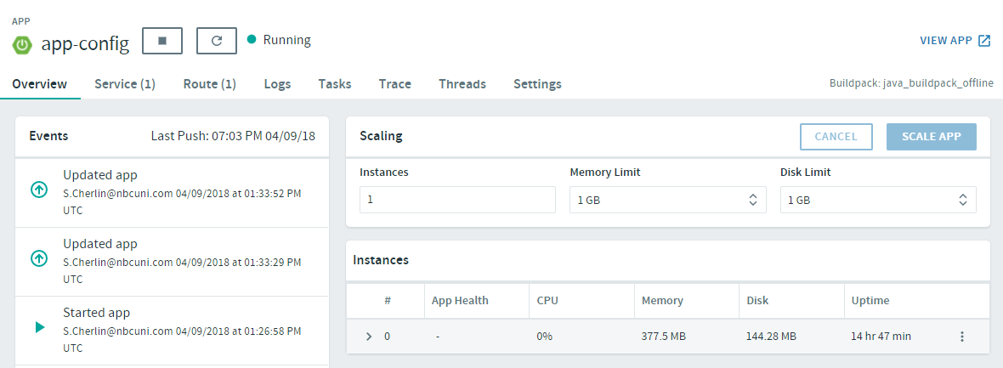

Config Server Service:

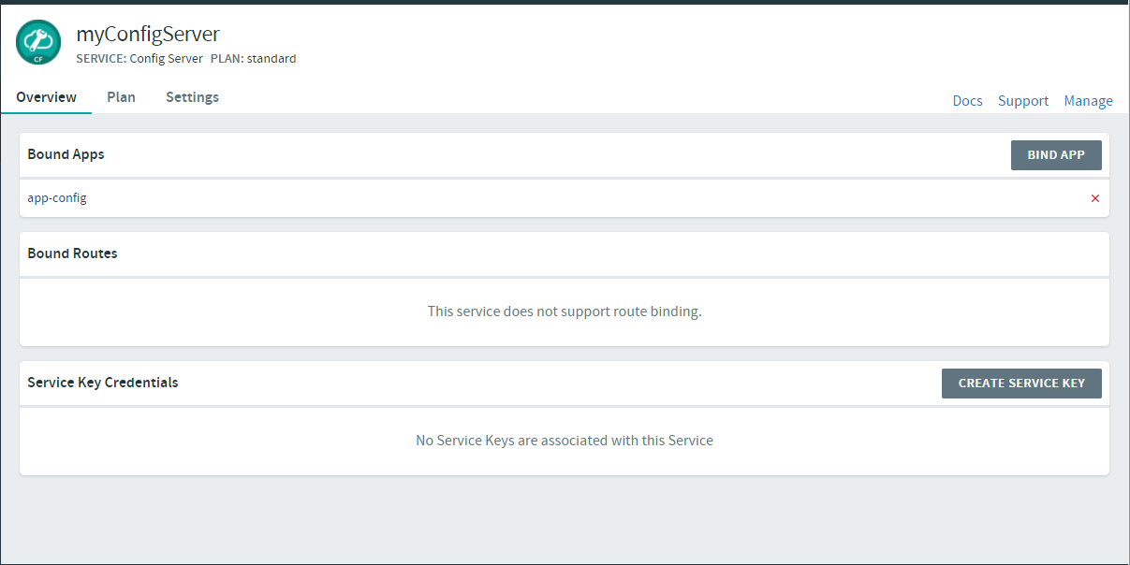

Git Repository Configuration with the config server

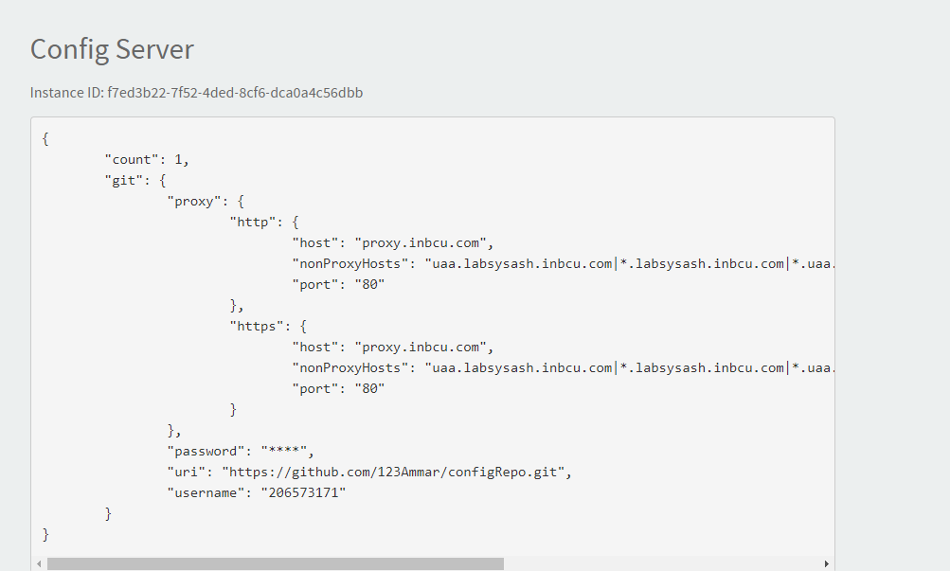

**Config Server Git Repository**:

GIT url: <https://github.com/123Ammar/configRepo>

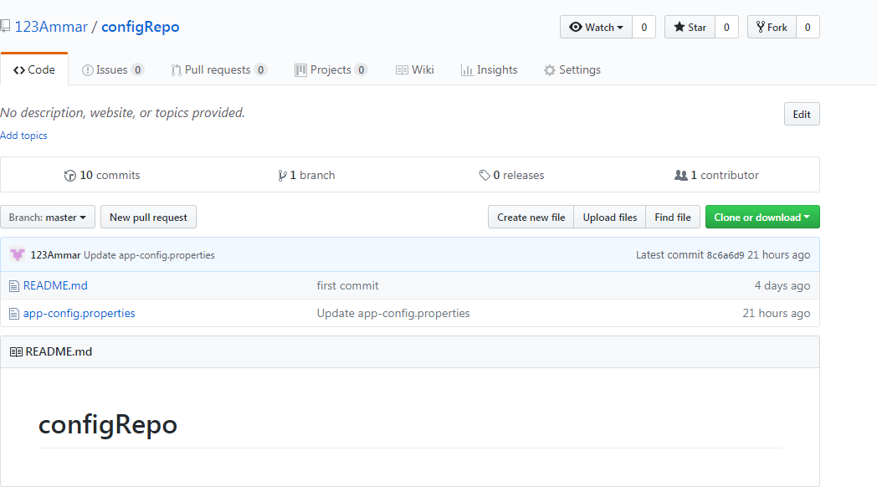

**app-config.properties**

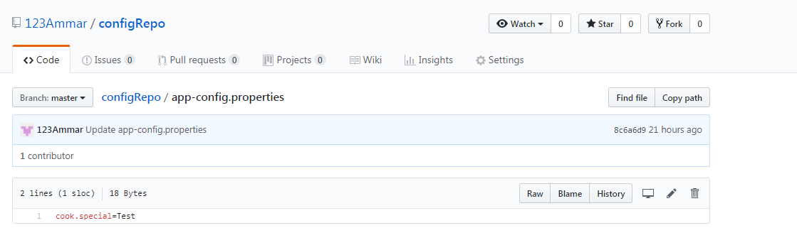

**Testing API:**

**URL (GET)**: https://app-config.labash.inbcu.com/restaurant

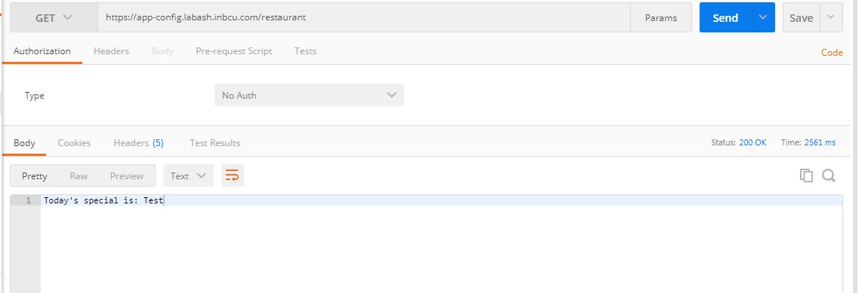

**Modified the properties file**

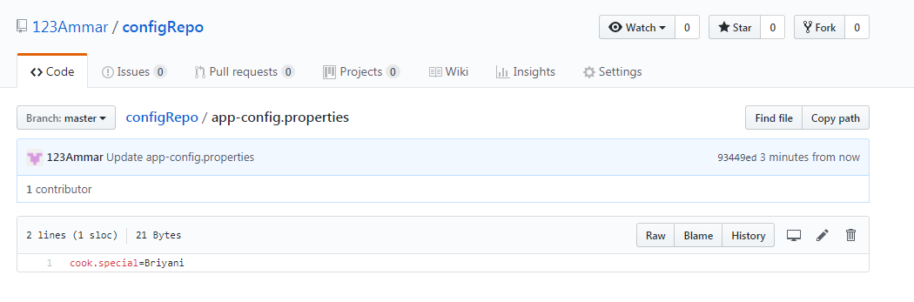

**We need to post the request in order to reflect the changes**

**URL (POST)**: https://app-config.labash.inbcu.com/**refresh**

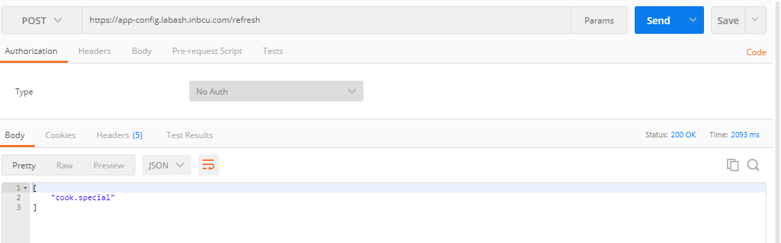

**URL (GET)**: https://app-config.labash.inbcu.com/restaurant

